

**NATIONAL UNIVERSITY OF SCIENCES AND TECHNOLOGY**

**“FUNDAMENTALS OF PROGRAMMING”**

**ASSIGNMENT # 03**

**SUBMITTED TO: Sir AFFAN**

**SUBMITTED BY: ABDULLAH**

**CMS: 461030**

**SEC-B ME-15**

# TASK NO1:

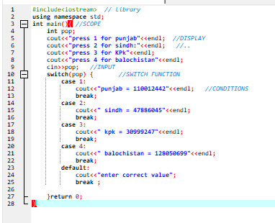

RESULT:

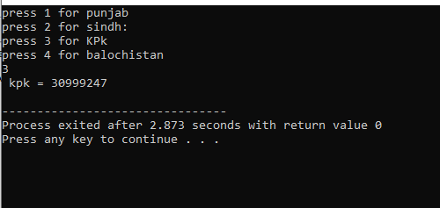

## TASK NO 2:

RESR

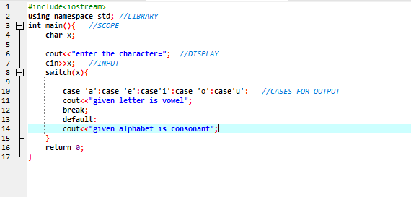RESULTS:

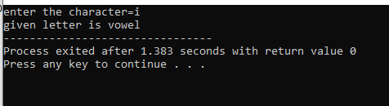

# TASK NO 3:

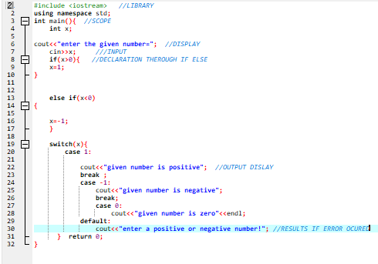

# RESULT:

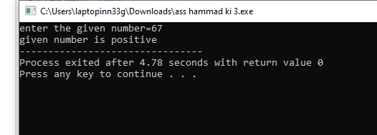

# TASK NO 4:

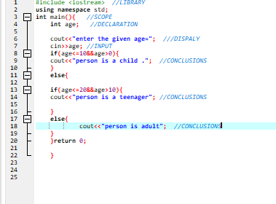

# RESULTS:

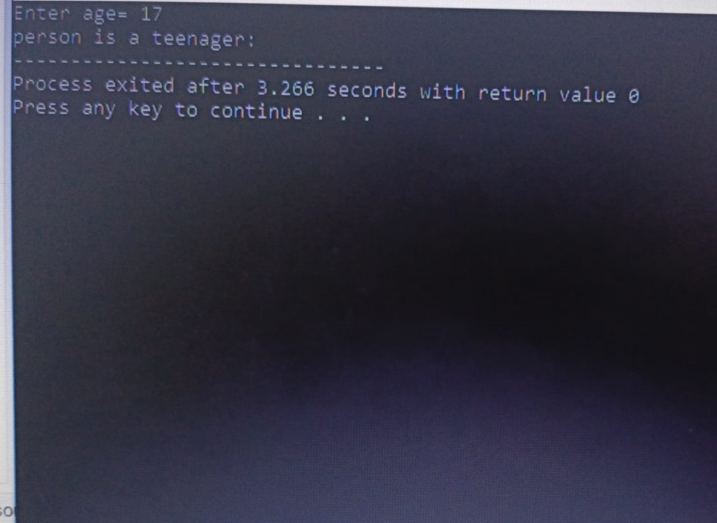

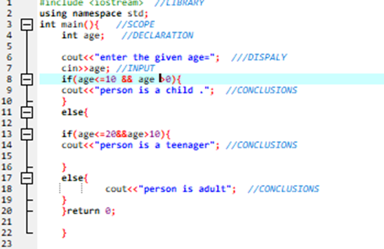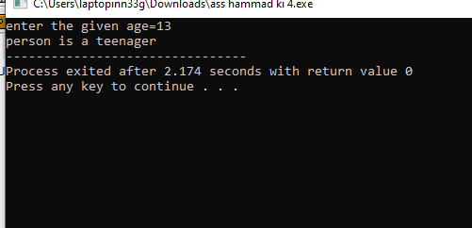

# TASK N0 5:

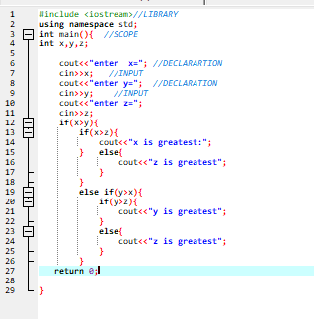

## RESULTS:

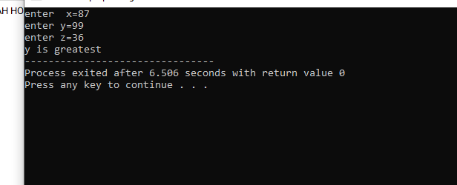

# TASK NO 6:

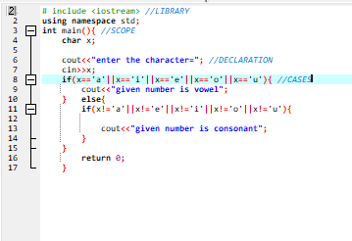

# TASK NO 6:

